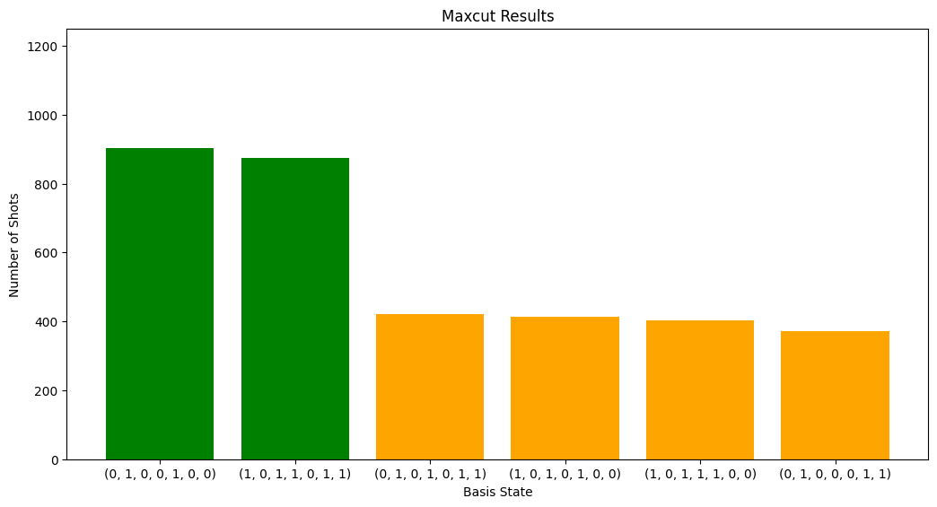
new highest energy found: 3.6374
new highest energy found: 3.6976
new highest energy found: 4.0868
new highest energy found: 4.549199999999999
new highest energy found: 4.925600000000001
new highest energy found: 4.965799999999999
highest energy: 4.965799999999999
best guess mixer angles: [ 1.209 -0.125 1.188]
best guess cost angles: [1.74 1.47 1.222]
CPU times: total: 4min 17s
Wall time: 4min 20s
Success ratio 0.3556

